**GE02 2.1 Documentation**

**Preface: These are the directions we received for 2.1. Comments on areas of possible complications will be blue and accompanied by screenshots below with the steps for fixing these issues.**

## 2.1 Create Virtual Environment and Django Project

These instructions show examples of working on a Mac for the commands. Note how you must run the commands on your environment.

* + A screenshot of a computer program

    Description automatically generated

1. Open the command/terminal window and check your python version. You should be using 3.11.

1. Create cs3300 folder then create portfolio folder for GE project

mkdir cs3300

cd cs3300

mkdir portfolio

cd portfolio

**Note: If you are new to navigating directories and want to jump to an entirely new location you can use the Set-Location command to go directly to the desired location by adding the path after the command. This is especially useful upon startup**



1. Create virtual env

python3 -m venv djvenv

Note: on different systems/setups the command may be py or python. You can find where they are located on your system by using where. This can also be useful for figuring out which command you need.

1. Activate virtual environment

source djvenv/bin/activate

**In windows this can be done without the source command. Also check your execution policy as windows defaults to not allowing the running of scripts in powershell. You can check and set this by doing the following.**

1. Install django in virtual environment (make sure it is version 4.2) [How tpio install django specific version? - Stack Overflow](https://stackoverflow.com/questions/77595193/how-to-install-django-specific-version)

pip install django

**Note: If pip comes up as a invalid command and you are sure python exists on your system you may need to take the following steps:**

**Then click on environment variables and select the path option in user variables. You then need to use your file explorer to copy the exact path from the scripts file in your djangovenv within your portfolio folder and add it to this list.**

**Click Ok**

**Restart powershell, navigate to portfolio and try pip again.**

1. Upgrade pip

python3 -m pip install --upgrade pip

1. Create django project

django-admin startproject django_project

1. Reorder directory structure for ease of use

Change from

to

mv django_project/manage.py ./

mv django_project/django_project/* django_project

rm -r django_project/django_project/

1. Run server and ignore migration warnings.

python manage.py runserver

**Note: If you receive an error stating that python cannot be found go to app execution aliases in settings and turn both python options off**

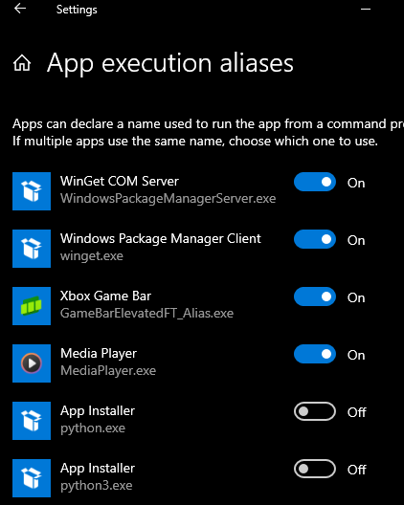

1. See if the installation worked by going to <http://localhost:8000/> and you should see. Celebrate!

1. Open the second terminal and activate the virtual environment.

Tip: I like to have 3 terminal windows tabbed: one for

* venv to run commands
* venv starting server and stopping server
* git/gihub commands

**Note use the previous command from above, again in windows no source is needed**

1. From virtual environment create requirements file of what is installed [Check all installed Python packages with pip list/freeze](https://note.nkmk.me/en/python-pip-list-freeze/)

pip freeze > requirements.txt

**Manage Project in VS Code**

You can use a different IDE but I will be demonstrating with VS Code.

Open the project in Visual Studio Code: In Visual Studio Code, go to `File -> Open Folder` and select the folder that contains your Django project.